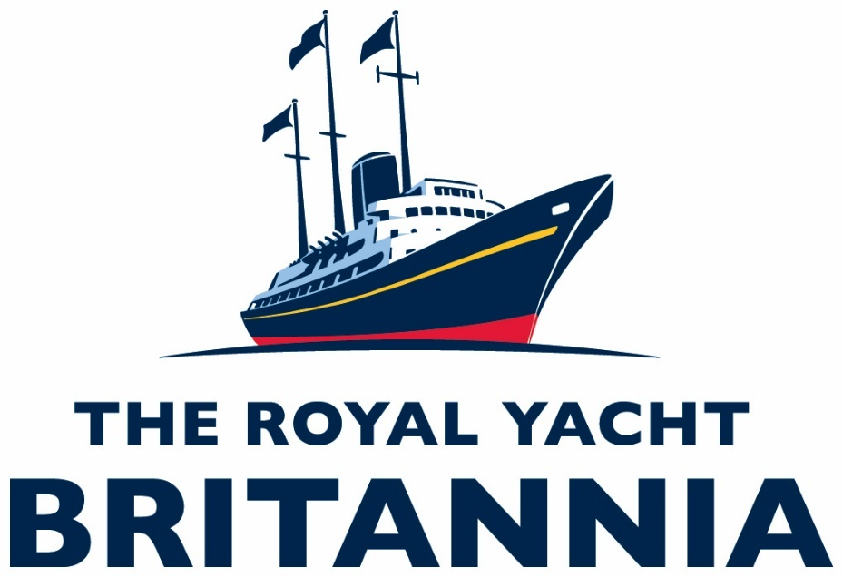

Access Statement
Updated March 2026
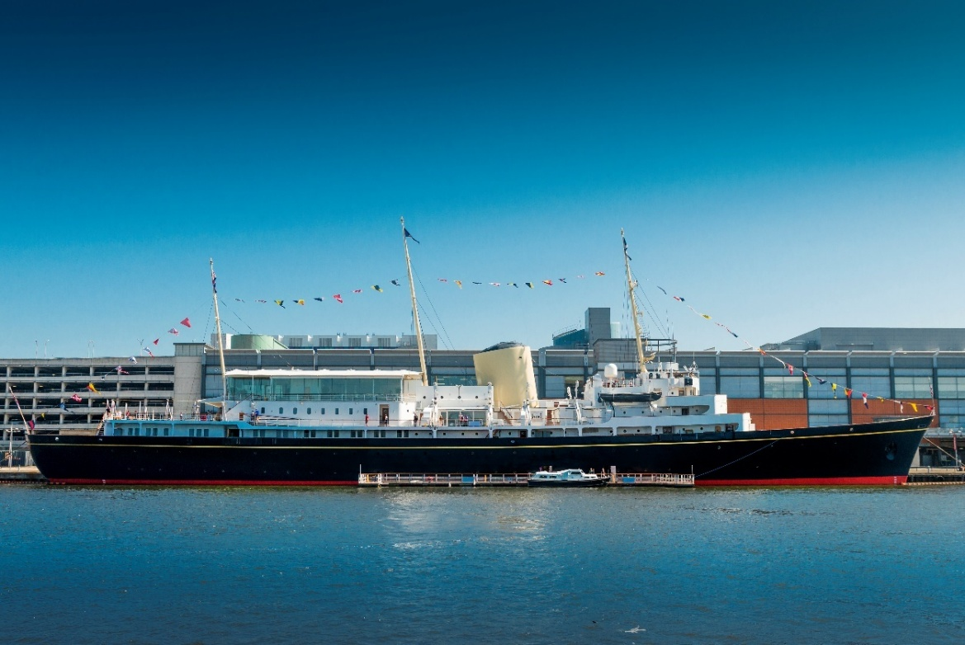
(Exterior of The Royal Yacht Britannia.)

The Royal Yacht Britannia, Ocean Terminal, Leith, Edinburgh EH6 6JJ (www.royalyachtbritannia.co.uk).
Contents Page

Access Statement Updated March 2026 1
General information 8
About us 8
Pre-arrival 9
By rail 9
By tram 10
By taxi 15
By bus 15
By bike 18
By car 18
Arriving by bus, tram, taxi, bicycle or on foot 22
Access from Ocean Terminal Main Entrance – Lift Access 26
Access from Ocean Terminal Main Entrance - Escalators 28
Wheelchair users 30
Buggies 30
Lift Tower 31
Arriving at our Visitor Centre 32
The tour 36
Signage 39
Britannia tour (displays, exhibits) 40
Public access on board 42
Lift tower 42
Onboard lift to the Royal Deck Tearoom 43
Doorways, floor coverings, lighting, stairs, ramps 44
Public Toilets 47
Inside Ocean Terminal Shopping Centre Two accessible toilets are located just inside the pedestrian entrance to Ocean Terminal Shopping Centre, on the ground floor to the right-hand side. 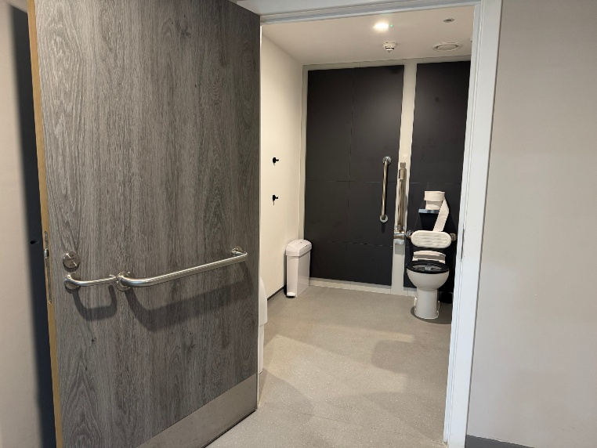 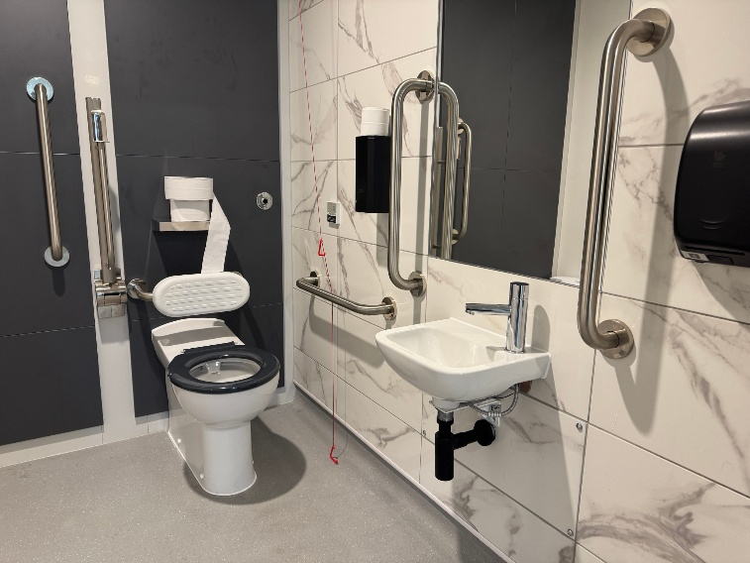 (Above left: The entrance into one of the accessible toilets at Ocean Terminal with handrails on the door and wall.) (Above right: Inside one of the accessible toilets at Ocean Terminal with wall mounted handrails and red emergency cord.) There are toilets situated on four levels aboard Britannia and in our Visitor Centre in Ocean Terminal. 47
Accessible Toilets On Board 50
Royal Deck Tearoom 51
Dietary requirements 52
Shop 53
Additional Information 57
Assistance dogs 57
Staff training 58
First aid 58
Smoking area 58
Local accommodation providers 58
Feedback 60
Contact information 60

This Access Statement does not contain personal opinions as to our suitability for those with access needs but aims to describe accurately the facilities and services that we offer all our visitors.

The Royal Yacht Britannia is an award-winning tourist attraction and exclusive use evening events venue, berthed in Leith, Edinburgh.

Entry is via Ocean Terminal Shopping Centre, which has a multi-storey car park, including dedicated accessible parking spaces on Levels C and E, and lifts. Please note there is a car park height restriction of 6.9ft (2.10m). We aim to provide a five-star experience to each and every one of your visitors.

Britannia has retained its Tripadvisor Travellers’ Choice Best of the Best Award, which is awarded to less than 1% of Tripadvisor’s listings.

The Royal Yacht Britannia is highly accessible for wheelchair users or those with specific access needs.
If you require any further information about specific access or need advice on planning your visit, please contact us:
+44 (0) 131 555 8800 or email enquiries@tryb.co.uk. Our office is open Monday to Friday 9am – 5pm.

If we have not covered your access requirements in this document, please contact us and we will be happy to discuss your needs, offer assistance where we can, and update this statement to offer the most up-to-date and informative details to ensure the best possible visitor experience.

General information

About us
- Britannia is berthed in Leith, Edinburgh, just 2 miles from the city centre.
- Access to Britannia is through Ocean Terminal Shopping Centre (2nd Floor of the shopping centre itself, from the Car Park, most directly accessible from Level E).
- We have British and American Sign language tablets, Braille script, an audio tour in over 30 languages, plain English, a version for the visually impaired and a children’s version in English of our tour.
- For opening dates and times, please see our website.
- Visitors are welcome to tour Britannia at their own pace. On average visitors take 1.5 – 2 hours, but please allow longer if visiting our Royal Deck Tearoom or wish to spend time in the Shop.
- We have accessible toilets within the Visitor Centre and aboard Britannia.

Pre-arrival
Our tour and Ticket Desk are on the 2nd Floor of Ocean Terminal. The centre is tiled throughout.

Please read on for how to get to Britannia.
We are just 25 minutes' drive from Edinburgh city centre. Our Visitor Centre is in Ocean Terminal on the 2nd Floor. You can get to The Royal Yacht Britannia by train, tram, bus, bike, car and taxi.

By rail
The nearest train station is Edinburgh Waverley, this is 2.3 miles from Ocean Terminal. There is a taxi rank nearby the station on East Market Street. It will take around 20-25 minutes by taxi to Britannia from Edinburgh Waverley. This may vary depending on the traffic.
- Now, go to page 21.

By tram
- This is a YouTube video that shows you how to find the Britannia Visitor Centre from the Tram, stop outside, via the lift inside Ocean Terminal:
www.youtube.com/watch?v=PNtN78JGqpk

- Edinburgh Trams frequently run from Edinburgh Airport through Edinburgh city centre and down to Leith.
- The tram stop at Ocean Terminal is located on Ocean Drive, outside Ocean Terminal Shopping Centre, in the centre of the road.
- To visit Britannia, get off the tram at the stop ‘Ocean Terminal’.
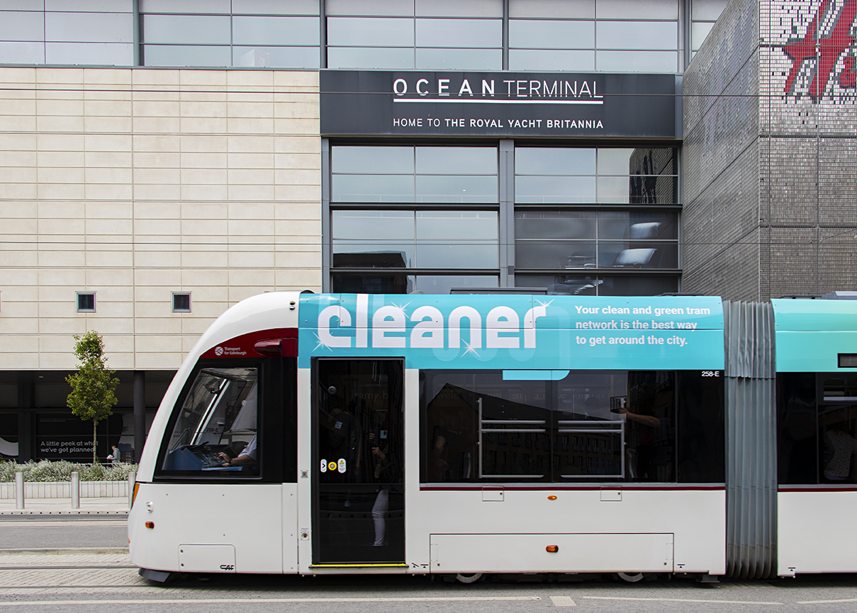
(Exterior of a tram with Ocean Terminal Shopping Centre in the background.)

- There is corduroy tactile paving at the tram stops and there is both corduroy tactile paving and a sloping pavement down towards the pedestrian crossing to cross over the road to Ocean Terminal Shopping Centre.

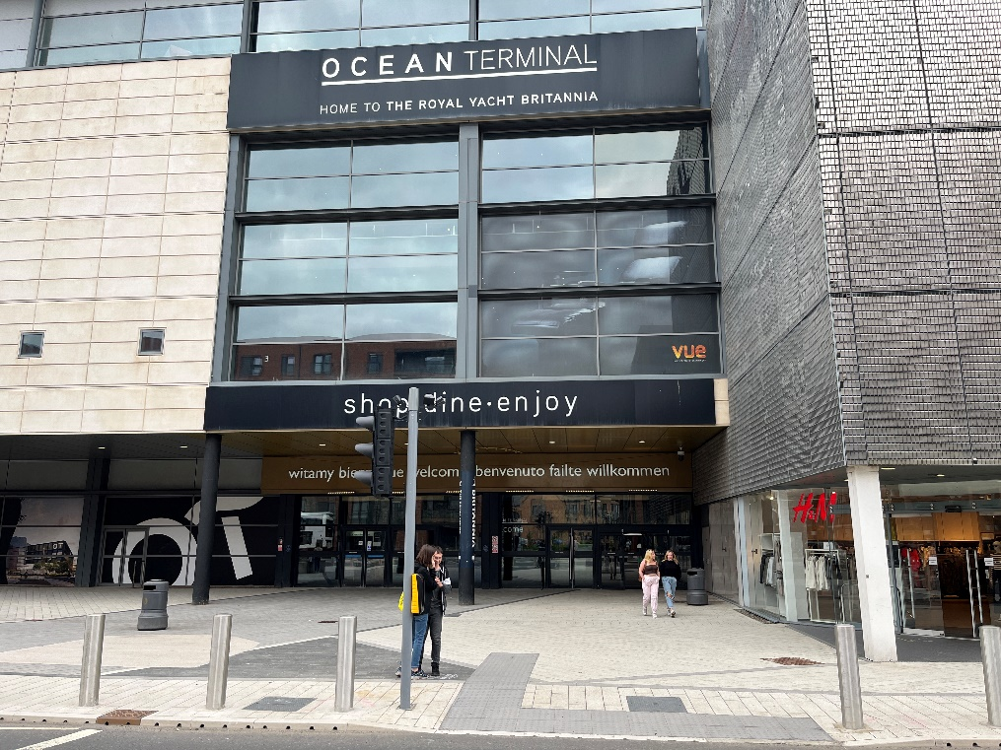
(Exterior of Ocean Terminal Shopping Centre showing the pedestrian entrance.)

- There are dedicated spaces for wheelchairs and mobility scooters on every tram, located in the middle carriage of the tram. A wheelchair symbol on the tram stop platform indicates where to wait.
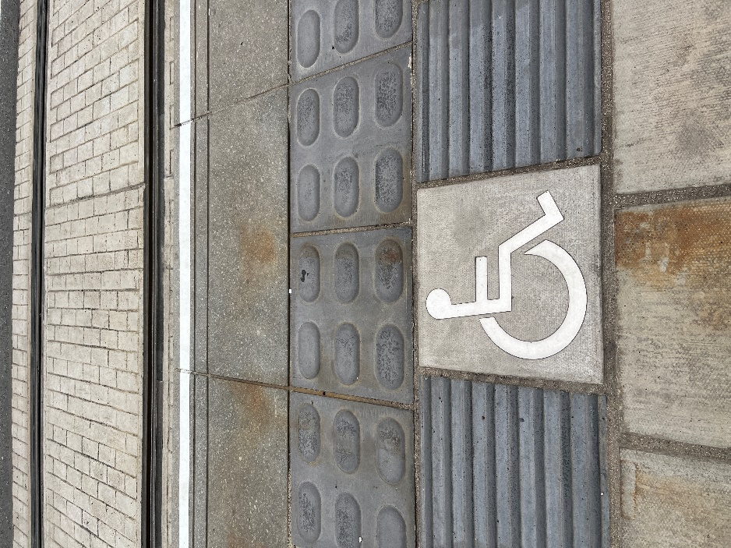
(Tactile paving and the International Symbol of Access on the platform.)

- Due to space limitations, the trams can only accommodate up to Class II mobility scooters.
- A single journey on Edinburgh Trams costs £2.20 each way in the city zone. Child tickets are £2.10 each way. If you are returning to the city, you can purchase a return ticket for the same day at £4.20 for adults and £1.90 for children. Tickets must be purchased from the machines on the platform before travel. Ticket vending machines accept most debit and credit cards including American Express as well as £2, £1, 50p, 20p, 10p and 5p coins. No change is given. If you are travelling to or from Edinburgh Airport there is a single ticket for £7.90 or an open return for £9.50.

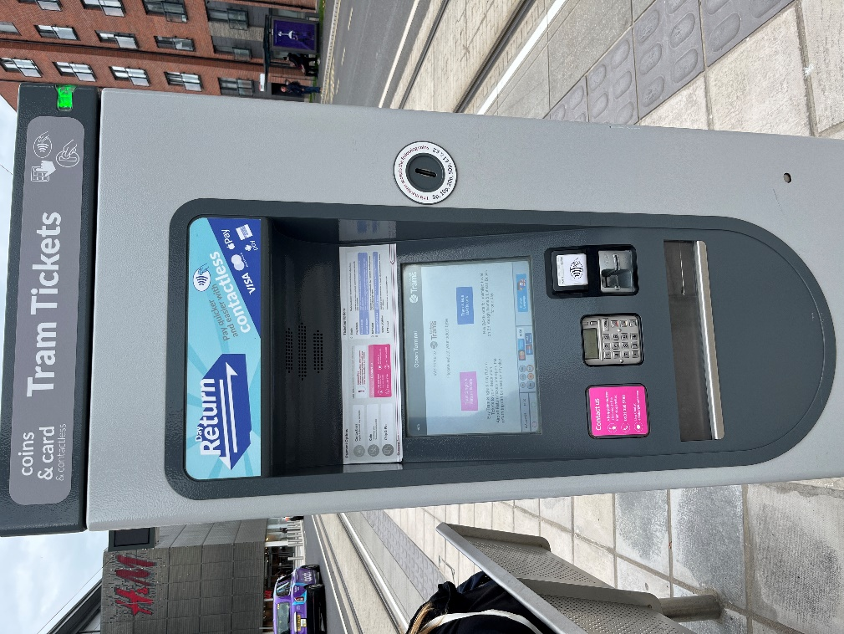
(Tram ticket machine.)

- If you have an Edinburgh Trams Ridacard or citysmart card this must be validated at the grey machine on the tram platform, before boarding. A journey has been deducted when the green tick comes up on screen. You must board within 30 minutes of validation.

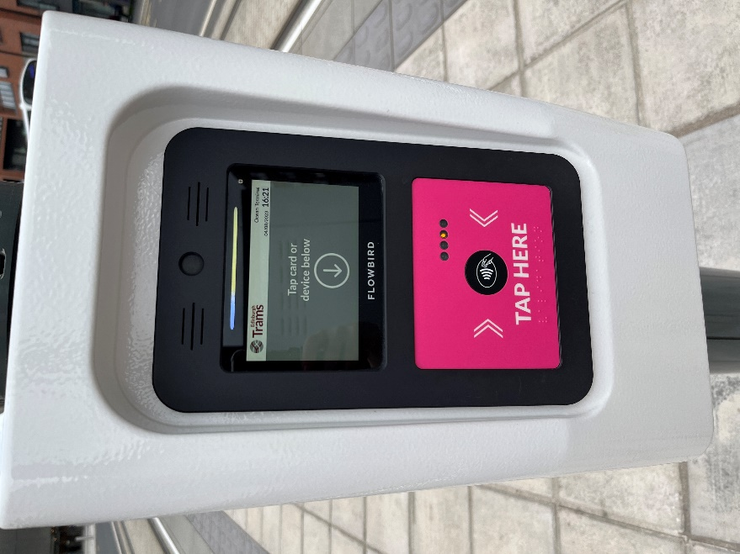
(Machine to validate tram tickets.)

Edinburgh Trams have:
- Low entrances throughout the vehicle.
- High visibility handrails.
- Two dedicated wheelchair/buggy spaces per tram.
- Dedicated disabled priority seats.
- Passenger alert buttons signposted in Braille for blind and partially sighted tram users.
- You can find more information on the Edinburgh Trams Accessibility page.
- Now, go to page 21.

By taxi
There is no designated taxi drop-off point. Taxi drivers will drop you off as close to Ocean Terminal as possible.

Our preferred taxi supplier is Central Taxis. All Central Taxis are wheelchair accessible. They offer a mix of 5-seater TX Hackney cabs, 6-seater Mercedes M8 taxis and Peugeot E7 taxis, each of which is supplied with a wheelchair ramp, seatbelts and additional safety anchors. All drivers have completed training in Wheelchair Access and Disability Awareness. Phone number 0131 229 2468.
- Now, go to page 21.

By bus
- Buses frequently run to and from the city centre as well as from Edinburgh Airport.
- Lothian Bus services from Edinburgh city centre are numbers 10, 16, 34, 35 or 36.
- The bus stops for buses 10, 34, 35 and 36 are located outside Ocean Terminal Shopping Centre on Ocean Drive, except the number 16 Lothian Bus, which is on Commercial Street. Commercial Street is at the crossroads with Ocean Drive and North Junction Street. The closest number 16 bus stop for Britannia is outside Leith Job Centre and the number 16 bus stop travelling back towards the city centre is on the opposite side of the road to the Leith Job Centre.
- The Regal Tour is a sightseeing tour bus. Regal Tour buses depart from Waterloo Place, just off Princes Street in Edinburgh’s city centre. The Regal Bus stops outside Ocean Terminal Shopping Centre.
- A single journey on a Lothian Bus is currently £2.20 and a child single journey costs £1.10. Please note you must have the correct amount (no change is given) or use a contactless card. A city day ticket is available for £5.50 or capped at £5.00 when the same contactless card is tapped for three or more journeys.
- The Lothian Bus Skylink 17 service travels directly from the airport to Britannia. Tickets can be purchased from the driver. Please note that the correct change is required.

All Lothian buses are easy access, they have:
- Low entrances that can “kneel” to kerb height to give step free access where possible.
- A retractable boarding ramp for wheelchair access.
- High visibility handrails.
- A dedicated wheelchair space.
- Drivers who are specially trained to help customers enjoy the full benefit of their buses.
- Now, skip to page 21.
- Now, go to page 21.

By bike
- There are bike racks situated at the front of Ocean Terminal. Please bring along your own lock to secure.
- Now, go to page 21.

By car
- This is a YouTube video which shows how to find the Britannia Visitor Centre from the car park: www.youtube.com/watch?v=7cKwNchOMlA

For satnav, our postcode is EH6 6JJ. Follow signs for Edinburgh and Leith, or North Edinburgh. Then follow brown Britannia signs. FREE parking is available at Ocean Terminal in a multi-storey car park. If arriving to The Royal Yacht Britannia by car, the best level to park on is level E. This is the same level as the Britannia Visitor Centre, however if this level is full, there are lifts and stairs to access Level E from the other Car Park levels, however if this level is full, there are lifts and stairs to access Level E from the other Car Park levels.
For information, there are EV charging bays for 12 vehicles, including two accessible bays, at Ocean Terminal, adjacent to the car park entrance.
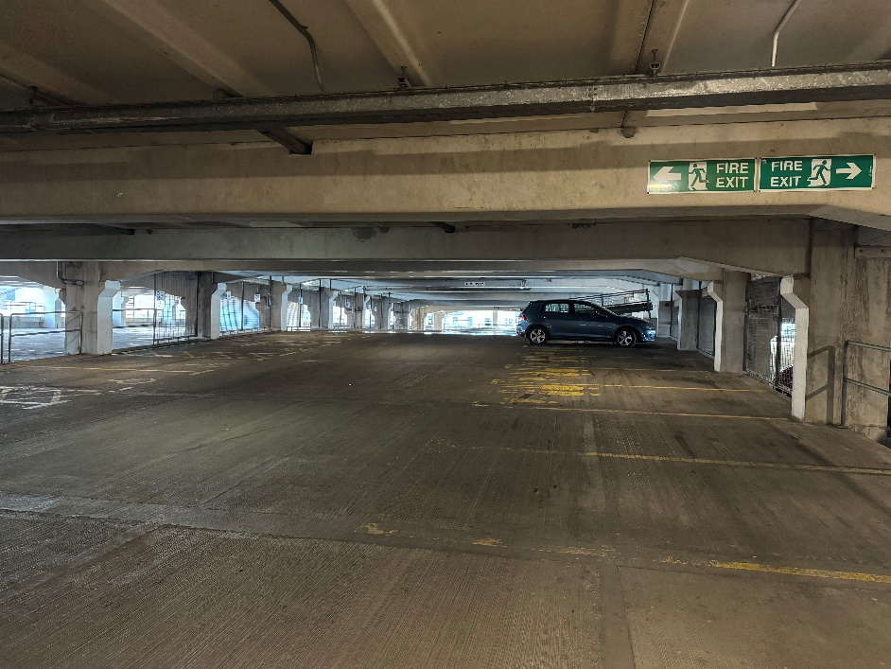
(Ocean Terminal multi-storey parking.)

- The nearest dedicated parking for wheelchair users and people with access requirements is in the multi-storey car park of Ocean Terminal on Level E.
- The surface of the multi-storey car park is concrete.
Ocean Terminal Free car parking:
Car park level | No. of blue badge car parking spaces
Level C | 22
Level E | 11

- In the multi- storey car park (Level E) there are 2 automatic outward opening doors on the left-hand side. The width of these is approximately 1560mm.
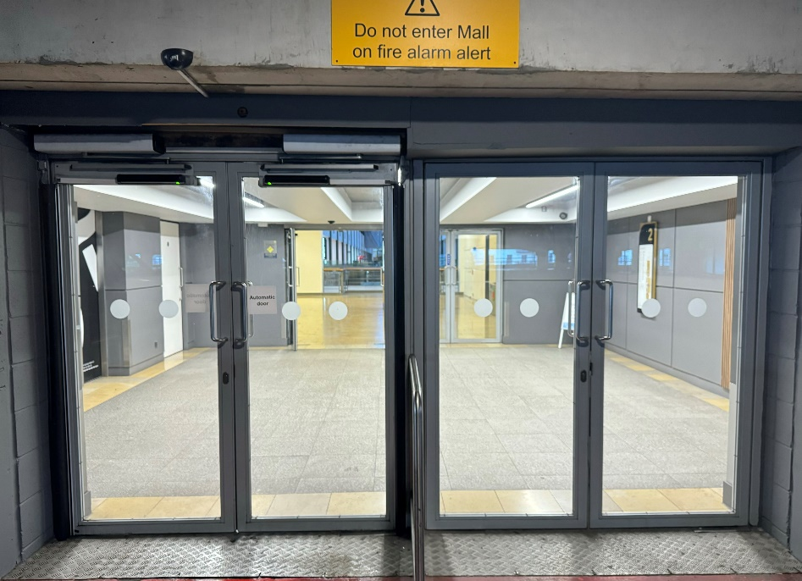

(Entering from level E of the car park into the 2nd floor of the shopping centre, with a set of outward facing automatic doors on the left and manual set of doors on the right.)

- After entering through the first set of automatic doors, each Car Park level has two lifts. If parked on car park levels A, B, C, D, F and G, take one of these car park lifts to level E.
- When on level E, you can enter the shopping centre through the next set of doors and go along to the far end of the shopping centre to the Britannia Visitor Centre.
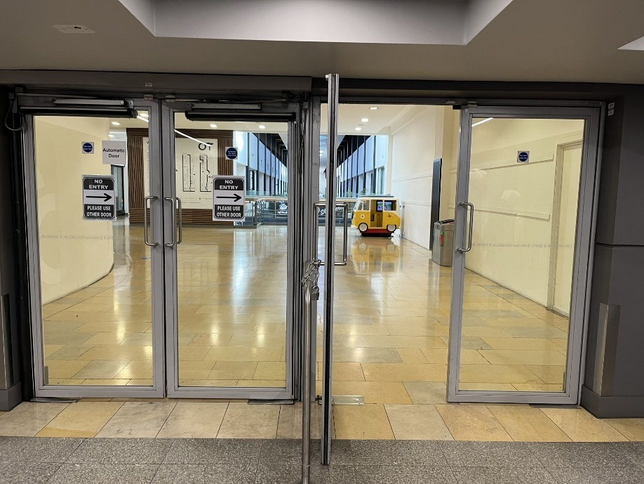
(2nd set of doors from car park Level E into the shopping centre.)

- On entry to the shopping centre from Level E, the entrance to our Visitor Centre is approximately 170 metres away.
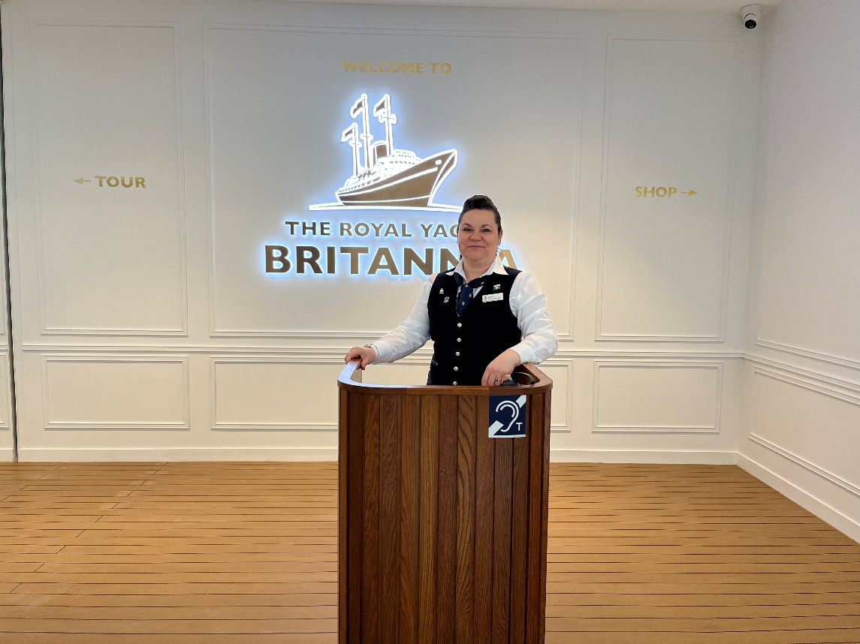
(The Visitor Centre entrance. A Welcome Host is at a podium to greet visitors. The podium may be just outside of the entrance.)

Arriving by bus, tram, taxi, bicycle or on foot
If arriving by bus, tram, taxi or if you are on foot, access to Britannia is from the Ocean Terminal Shopping Centre main entrance on the Ground Floor.
Take the lift to the Second Floor.

Please note that you will not see Britannia as the Yacht is permanently berthed behind the shopping centre.

Outside Ocean Terminal (left-hand set of doors)

The main entrance to Ocean Terminal is at street level. There are 4 double sets of doors. The first pair of doors on the left open outwards automatically.
The second pair of doors are manual. Each has a width of 1570mm.

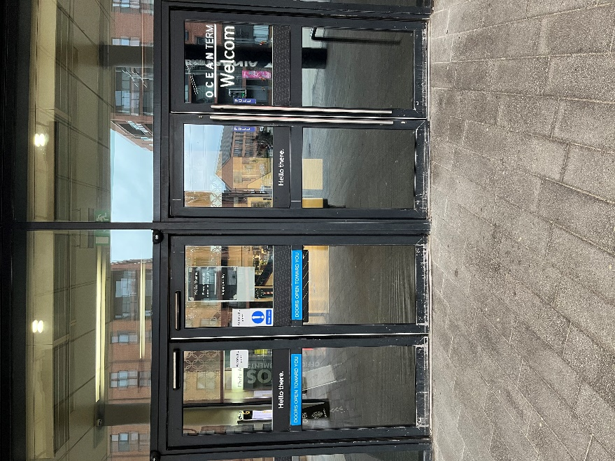
(First set of outer doors to Ocean Terminal. The doors on the left open automatically. A set of manually opened doors are shown to the right.)

Within Ocean Terminal (left-hand set of doors)

Once inside Ocean Terminal, there is a second set of doors. The pair of doors on the left is opened by a push button. The set of doors on the right are opened manually.

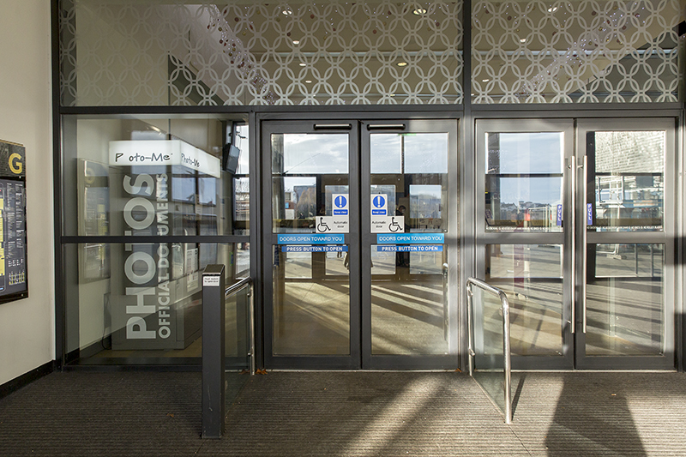
(The inner set of doors inside Ocean Terminal)

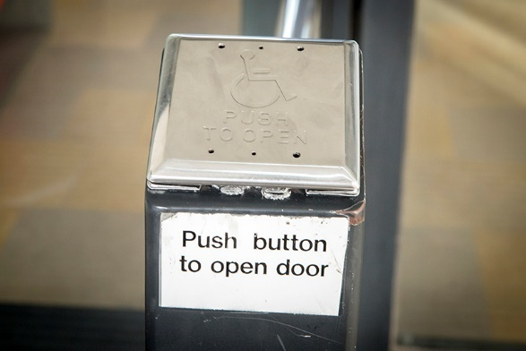
Push button access

(The doors on the left are opened by a push button.)

Outside Ocean Terminal (right-hand set of doors)

The third pair of doors are manual and the fourth pair of doors are automatic inline sliding doors.

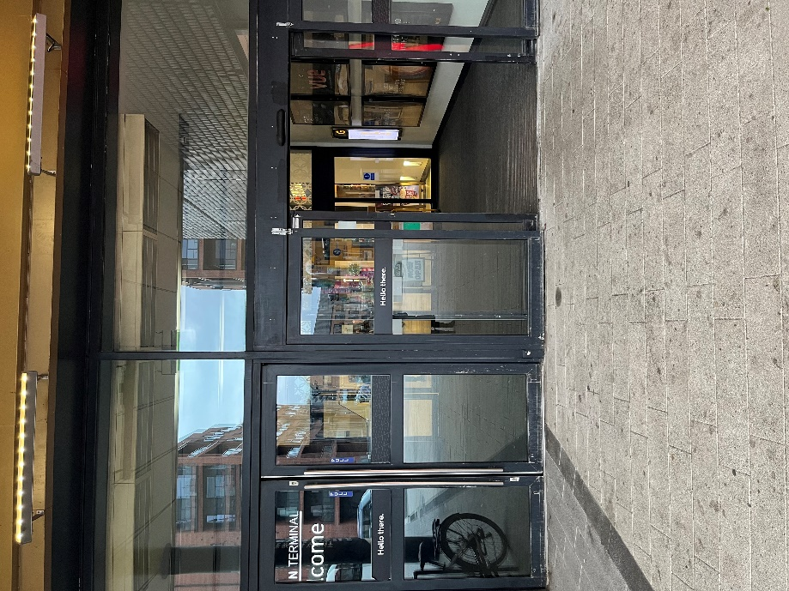
(Right-hand set of doors to Ocean Terminal.)

Inside Ocean Terminal (right-hand set of doors)
Once inside Ocean Terminal, there are a pair of manual doors on the left side and a pair of inline sliding doors on the right.

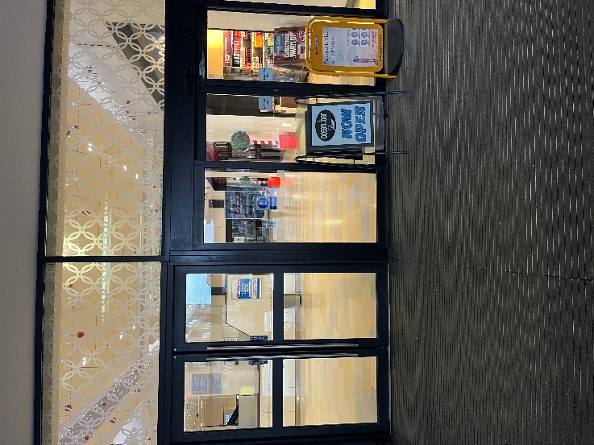
(Within Ocean Terminal there is another set of doors. A pair of manual doors on the left and a set of automatic doors slide open on the right-hand side.)

Access from Ocean Terminal Main Entrance – Lift Access
From the main entrance to Ocean Terminal, enter the shopping centre. Go ahead towards Boots and turn right. Proceed along the concourse, past H&M to find the lift tower which is black, to go up to the second floor. The entrance to the lift faces towards the Shop Holland & Barrett.
- The lift inside Ocean Terminal Shopping Centre has a button for emergencies and can take up to 1600kg of weight, maximum 21 people.

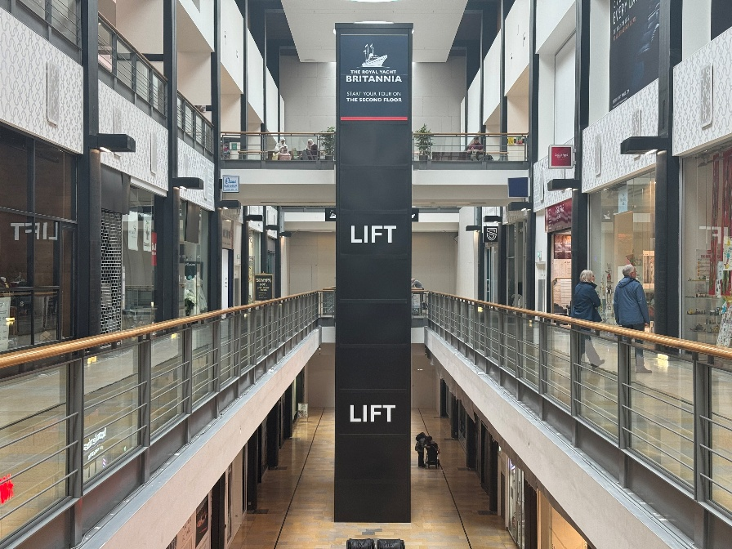
lift tower
(The lift tower inside Ocean Terminal.)
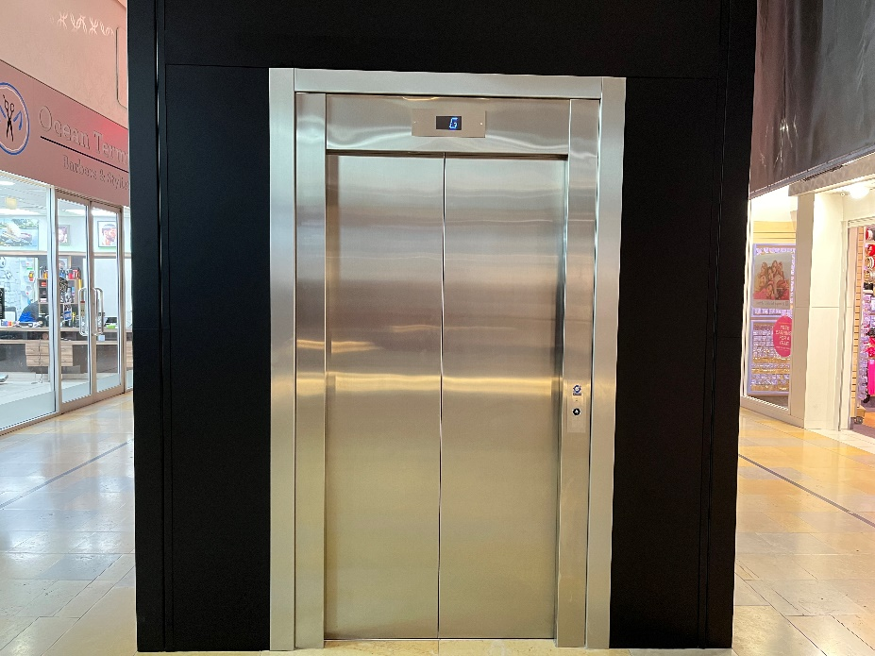
(Lift access to Britannia within Ocean Terminal Shopping Centre. This lift has a width of 1002mm.)

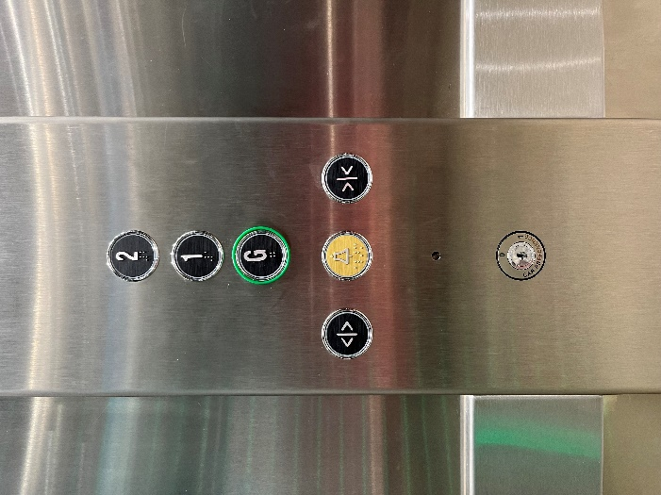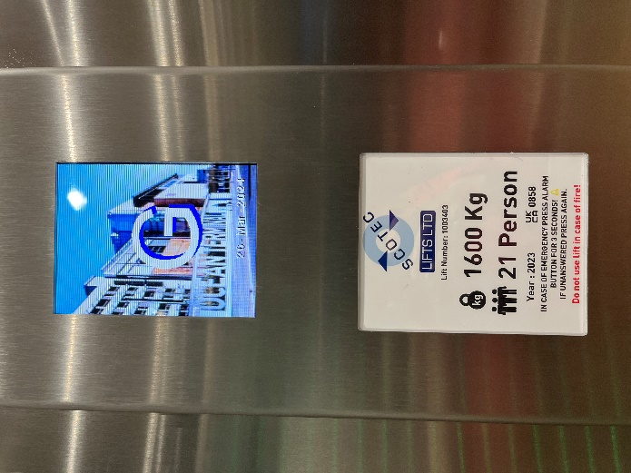
(Left image shows the lift buttons inside the Ocean Terminal lift. The right image shows the floor level display within the lift.)

- When you exit the lift, the Visitor Centre is on the left-hand side.

Access from Ocean Terminal Main Entrance - Escalators
- Alternatively, go straight ahead from the main entrance to Ocean Terminal and take the escalators to the 2nd floor to start the tour.
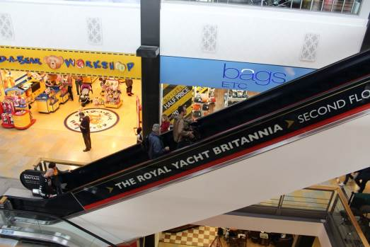
(Escalator from the 1st floor to the 2nd floor.)

Wheelchair users
- To access the whole tour, wheelchairs should be no wider than 670mm, in order to negotiate some narrow passageways and corners.
- If your wheelchair exceeds 670mm in width, we have two wheelchairs available onsite, at no cost to borrow. Please note our wheelchairs do not have lap seat belts. Please ask to use a wheelchair at the Ticket Desk.
- Please note: Shopmobility scooters and electric wheelchairs are generally unsuitable on Britannia due to the gradient of the ramps on board.
- Britannia is classed as Category 1, the highest level for wheelchair access without assistance, by VisitScotland.

Buggies
- Buggies are welcomed on board Britannia. All but the widest double buggies will have full access to the Britannia tour (max width 670mm). We have baby changing facilities at the four sets of toilets on board plus one at the Visitor Centre.
- The baby changing facilities in the Visitor Centre have motion sensor lighting and the door open outwards towards you.
- We have highchairs in the Tearoom.

Lift Tower
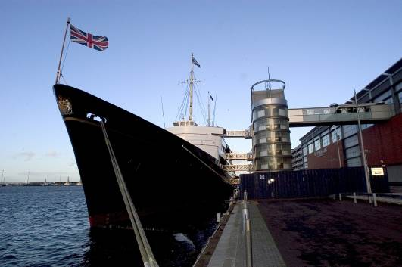
Lift Tower

(The Royal Yacht Britannia, with lift access to five decks via the Lift Tower, pictured above.)

Each of Britannia's decks are accessed via a shore-side Lift Tower and stairwell. Any seats without ropes or signage are there for you to sit on and enjoy your audio tour.

Arriving at our Visitor Centre
On arrival at the 2nd Floor of Ocean Terminal, you will find our Visitor Centre at the East end of the building. The floor is made of smooth replica wooden decking. There are no steps at the Visitor Centre.

There is a welcome desk on arrival to our Visitor Centre, which is always staffed. If you have pre-booked your tickets, the Welcome Host at the welcome desk will ask to see your tickets.

We have hearing induction loops throughout Britannia, including at the Welcome Host podium, the Ticket Desk, Welcome Talk area, the Handset Desk and in the Shop. There is also complimentary Wi-Fi throughout.

There is seating available outside the Britannia Visitor Centre.

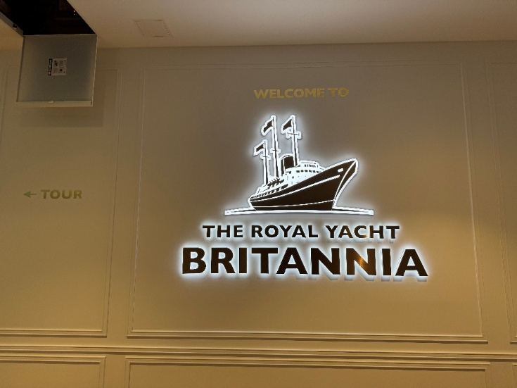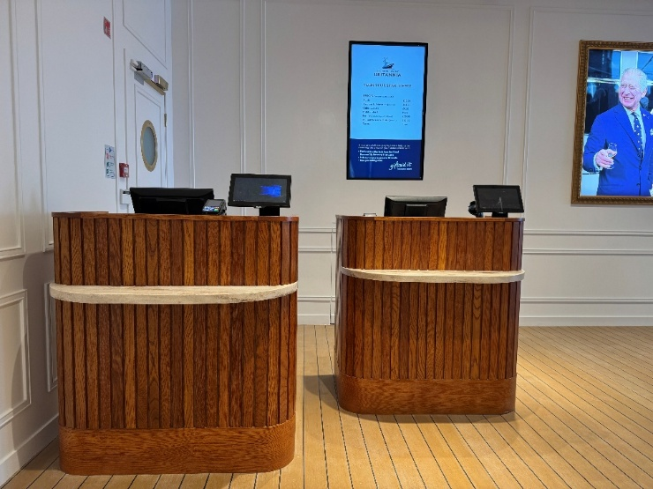
(Above: Inside the Visitor Centre there are two ticket desks. At least one will be staffed until last admission time.)
There is a lower shelf counter on the front of each desk, pictured below. The payment/information desk area has a hearing loop.

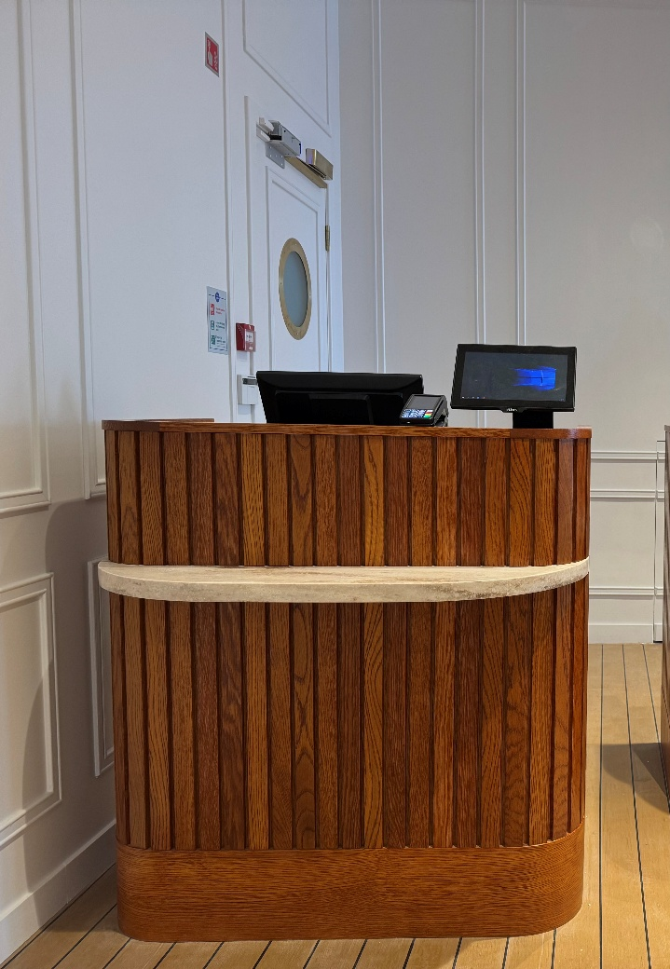

There are two TV screens, one screen in the queue line, one behind the Ticket Desk.

We can offer a pen and pad of paper to assist people in purchasing ticketsand also have a magnifying glass available.

Tickets can be purchased for the Britannia tour from the ticket desk, or in advance online via our website – www.royalyachtbritannia.co.uk.
Should a complimentary carer ticket be required, this can be requested at the Ticket Desk on the day.

To reach Britannia from the Visitor Centre, visitors will go through an exhibition. The flooring changes between the Ticket Desk area and the exhibition from smooth replica wooden decking to dark coloured linoleum.

Upon entering the exhibition, there is a large window straight ahead that overlooks Britannia from a height. The bottom section of the window is semi-transparently covered.

Following the Visitor Centre, visitors will go through a bridge walkway. The upper half of the walkway has windows that look out at height over Britannia.
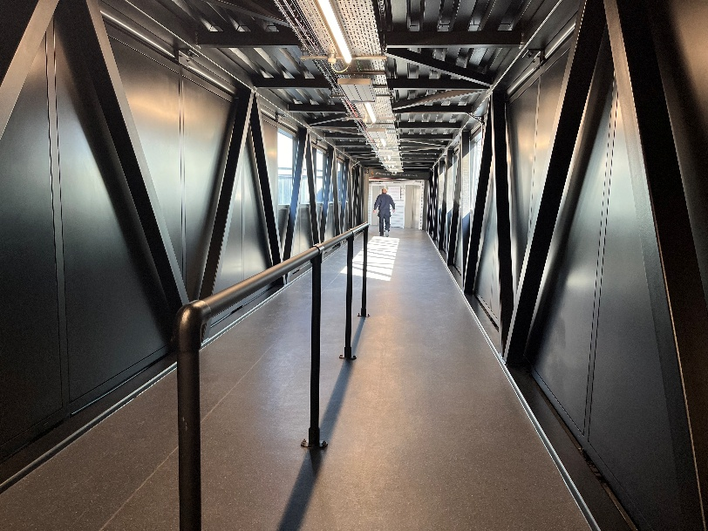
(Bridge walkway connecting the Visitor Centre to the ship.)

The tour
Our audio tour is available in over 30 languages, a plain English version, a version for the visually impaired and a children’s version in English. Visitors with learning difficulties or those whose first language is not English may find the plain English audio tour suitable.

The tour is available in British or American Sign Language on a tablet. We also offer the tour in Braille script. We have a printed version of our English language tour in large font – please request this at the Handset Desk before you make your way on board Britannia. We have Visitor Assistants situated throughout our tour, who are on hand to answer questions and help where possible.

At the Handset Desk we have straps which allow the audio guides to be worn around the neck. Headphones are also available.
The audio tour is also available to listen to on your mobile phone during the tour. We encourage our visitors to bring their own headphones but there are disposable headphones available. This is available by scanning a QR code.

Our audio handsets have adjustable volume control, so you may wish to also take the handset tour.

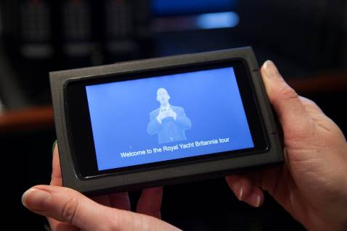
(Britannia’s British Sign Language Tablet.)

We have Visitor Assistants situated throughout our tour, who are on hand to assist our visitors. The Visitor Assistants are smartly dressed in Britannia’s tartan and in colder weather have a red jacket.
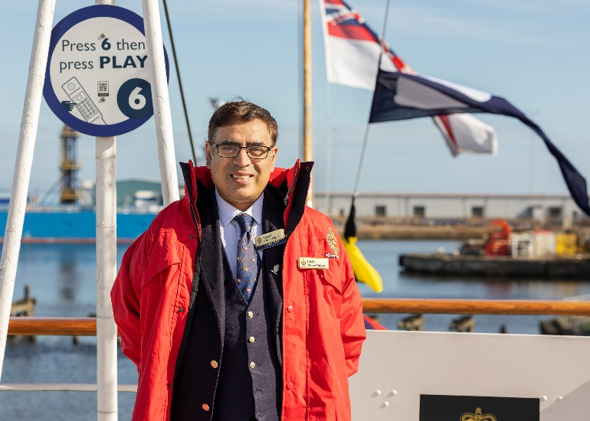
Sensory packs are available from the Handset desk, similar to as pictured.
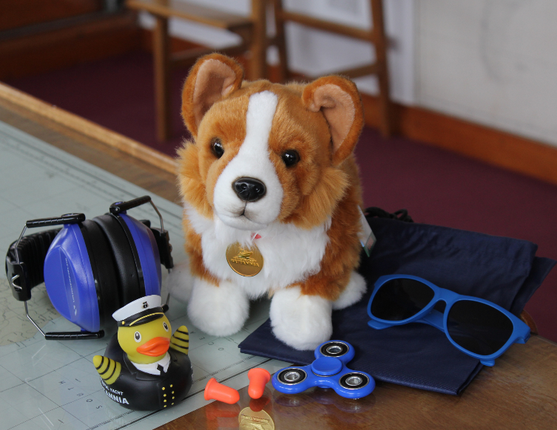
(Sensory pack.)

Signage
General signage on board Britannia is white with navy blue text. The disc signs throughout the tour advise visitors which numbers to press on their audio handset tour and signify the colour of deck they are located on. Each deck has a colour, namely red, blue, gold, purple and grey.
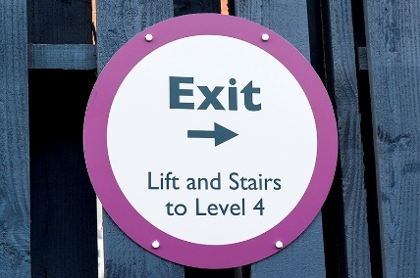
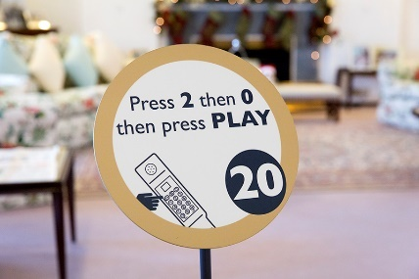
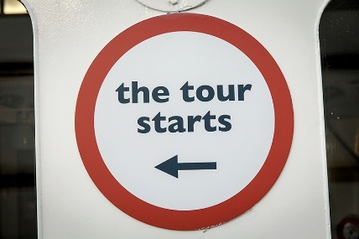

(Three signs on the tour route.)

Britannia tour (displays, exhibits)
- Many exhibits on board have a descriptive sign next to them in English.
- There are no displays that use flashing lights.
- A video is playing upon arrival into the exhibition.
- There is a TV screen playing a video of Queen Elizabeth II.
- There is a wall of lightboxes and four videos playing on screens when you first enter the exhibition and turn right.
- Another video is playing further into the exhibition when you turn left.
- Before the Handset Desk, a video is playing that shows how to use the handsets.
- The floor surface changes from dark coloured lino to replica decking linoleum.
- There are Visitor Assistants located along the route who will be delighted to help with any queries or requests.
- There is background noise/music in the Visitor Centre, on the Bridge, in the Wardroom Anteroom, State Drawing Room, State Dining Room, Royal Marines’ Barracks, Chief Petty Officers’ Mess, Petty Officers’ Mess, Laundry, Royal Sailing Exhibition, Visitor Centre, Tearoom and Shop. Music is also played in the toilets on the Grey Level, and on the Blue Level on the Port side.
- Videos with sound play in the Petty Officers’ and Royal Marine Sergeants’ Mess.
- To enhance the experience, scents are used in the Sick Bay (TCP) and Laundry (soap powder). Air fresheners are in use in all four toilets on board and in the Visitor Centre toilets. Additionally, as fresh food and fudge are prepared on board you may smell cooking on the Blue Level Port Side, Galley Corridor and near the NAAFI.

Public access on board

Lift tower
A lift tower on the quayside gives access to Britannia’s five decks, with lifts to every level and ramps onto the ship.

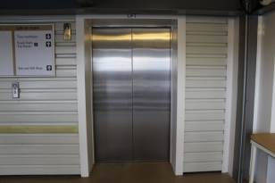

(One of two lifts in the Lift Tower.)

The lift tower takes visitors to all decks and opens at all levels. It is 1100mm in width.

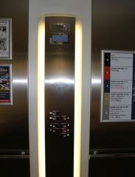
(Inside one of the lifts in the Lift Tower.)

Onboard lift to the Royal Deck Tearoom
The original lift on board Britannia has a manual opening/shutting door and an automatically closing inner door. Please note that the manual doors are heavier to open/close between. The door width is 750mm. This lift offers access to the Royal Deck Tearoom and the State Apartments.

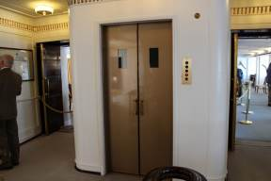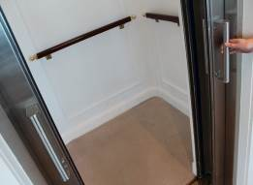
(Both images above show the onboard lift. The left shows the lift at the State Apartments level. The image on the right shows the inside of the lift.)
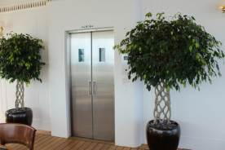
(The lift doors as seen from within the Royal Deck Tearoom.)

Inside the lift, there is a panel with buttons, please press the buttons on the left side. The maximum lift load is 1200lbs or 544kg.

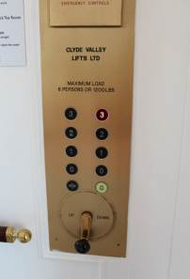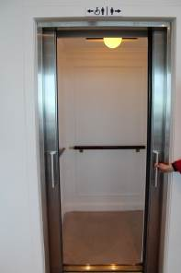
(The picture above on the left shows the buttons inside the lift. The image on the right shows the doors open at the Royal Deck Tearoom level.)

Doorways, floor coverings, lighting, stairs, ramps
Floor surfaces aboard the ship vary from wooden decks, short pile carpet, checker plate flooring, replica wooden decks, linoleum tiles to ceramic tiles. Outside on the Quayside, the floor surface is concrete with ramps between the lift tower, Garage and Engine Room.

Lighting throughout Britannia is very good, with natural light and fluorescent and LED tube lighting.
There are a few access points to note:
- At point 11 of the audio guided tour: The doorway on exit from the Officers’ Wardroom is 780mm width and has a light wooden door.
- There are 2 ramps allowing access to and from the Verandah Deck, with handrails either side.
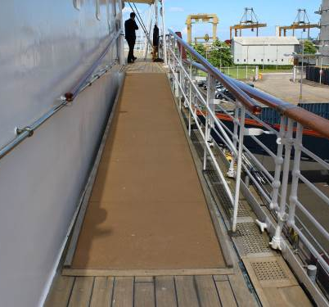
(Ramps aboard Britannia leading away from the Verandah Deck.)

- If the lift is not required to access The Royal Deck Tearoom, there are external stairs up from the Verandah Deck. There are 15 stairs, with handrails either side. These stairs are original, and narrower in depth than the other staircases on board.

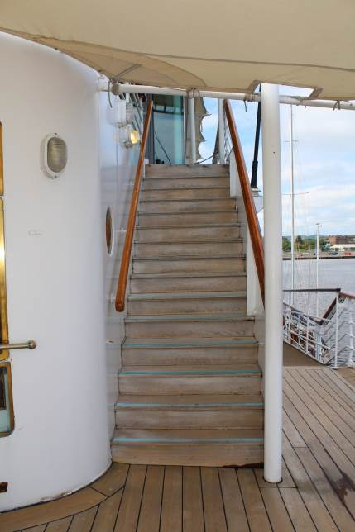
(Stairs to The Royal Deck Tearoom.)

Public Toilets

Inside Ocean Terminal Shopping Centre
Two accessible toilets are located just inside the pedestrian entrance to Ocean Terminal Shopping Centre, on the ground floor to the right-hand side.
Door width: 1000mm
Distance from door to seat: 1630mm
Toilet seat height: 470mm
(Above left: The entrance into one of the accessible toilets at Ocean Terminal with handrails on the door and wall.)
(Above right: Inside one of the accessible toilets at Ocean Terminal with wall mounted handrails and red emergency cord.)
An accessible toilet is also on the first floor. A radar key is required for access.
Accessible Toilets On Board
There are toilets situated on four levels aboard Britannia and in our Visitor Centre in Ocean Terminal.
There is an accessible toilet in the Visitor Centre which is located after the Ticket Desk.

Between the Ticket Desk and the public toilets, the floor changes from smooth replica wooden decking to timber vinyl.

Visitor Centre (after the Ticket Desk and before the exhibition.)
Door width: 860mm
Distance from seat: 1450mm
Seat height: 490mm

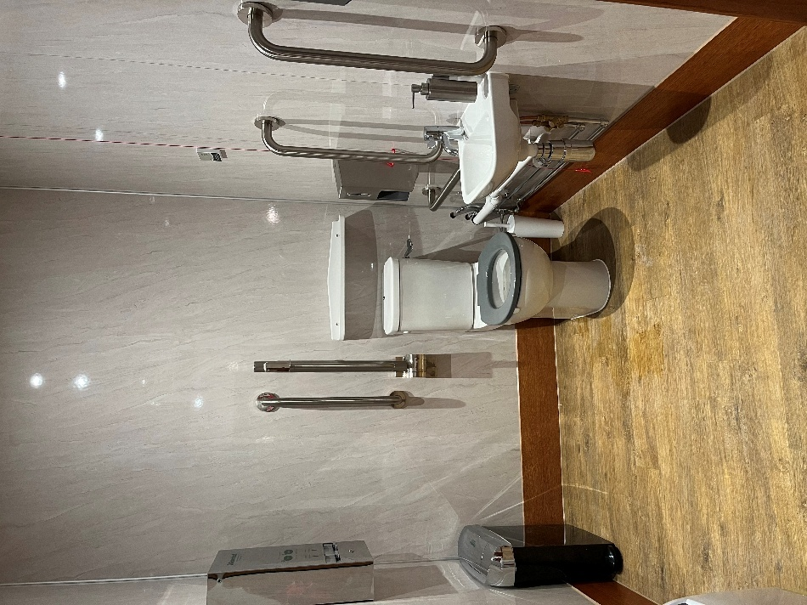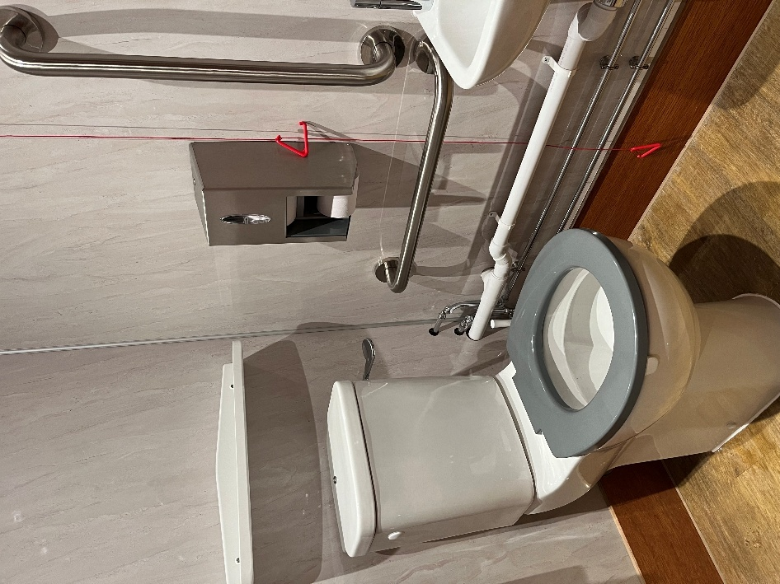

(Above left: The accessible toilet after the Ticket Desk containing support handles and a red emergency cord. Above right: A close-up of the toilet and support handles.)

There is also a non-accessible toilet before the Handset Desk in the Visitor Centre.

Accessible Toilets On Board
Tearoom
Door width: 1000mm
Distance from seat: 1200mm
Seat height: 465mm

Sailing Exhibition
Door width: 860mm
Distance from seat: 1000mm
Seat height: 490mm

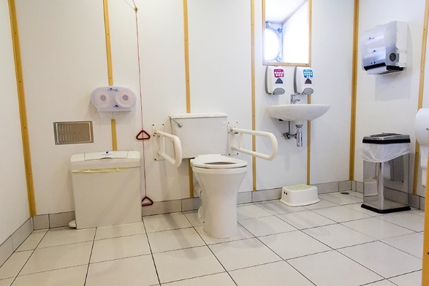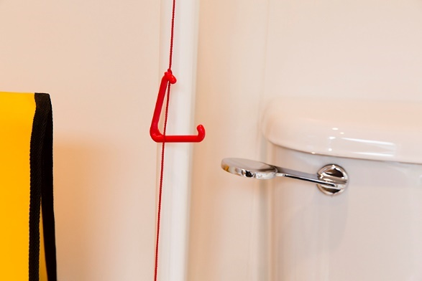

Gold level
Door width: 800mm
Distance from seat: 1200mm
Seat height: 560mm

Grey level
Door width: 800mm
Distance from seat: 1400mm
Seat height: 510mm
Please note, there is a slight slope in this toilet, due to the camber.

Royal Deck Tearoom
The Royal Deck Tearoom is situated on board Britannia. It is highly accessible for wheelchairs and buggies less than 670mm in width by internal lift from the Royal Bedrooms. The Tearoom is not accessible by Shopmobility scooters. The tables and chairs are moveable for wheelchair access.

- There are 15 steps up to the Tearoom from the Verandah deck. The door width is 1010mm and has a raised lip, which is highlighted with tape.
- The Tearoom has 35 tables and can seat 133 people. Table height is 720mm with chairs without arms. Guests are waited on with table service, by our staff.
- There are floor to ceiling windows throughout, as well as spotlighting.
- The flooring is the original wooden deck.
- Our staff will happily read out the menu to customers. A magnifying glass and reading glasses are available, on request. Please ask a member of our staff.
- Crockery is white, with silver teapots and cutlery. Our tabletops are cream coloured. There is an accessible WC within the Royal Deck Tearoom.
- There are highchairs available for younger children and baby changing facilities.

Dietary requirements
- The menu caters for vegetarians and vegans and there are gluten-free and dairy-free cakes, scones, soups and sandwiches available.
- We also have gluten-free bread available for our sandwiches and our potato wedges are gluten and dairy free.
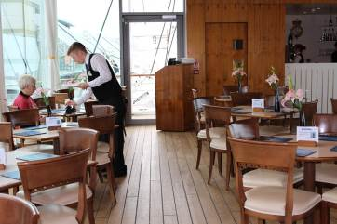

(Royal Deck Tearoom showing spacing between tables.)

Shop
- Britannia’s Shop is located within Ocean Terminal Shopping Centre, adjacent to the Visitor Centre entrance and can be accessed at the end of the tour, or directly from Ocean Terminal, without having to visit Britannia itself.
- Access from Ocean Terminal is via an open doorway with a width of 1460mm.
- The flooring within the shop is replica wood and carpet and is level throughout. The tables and fixtures have spacing throughout to enable those in wheelchairs and pushchairs to browse the Shop. Fixtures include shelving units, tables and gondolas.
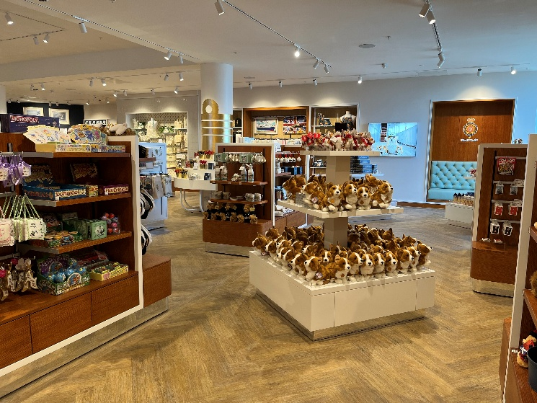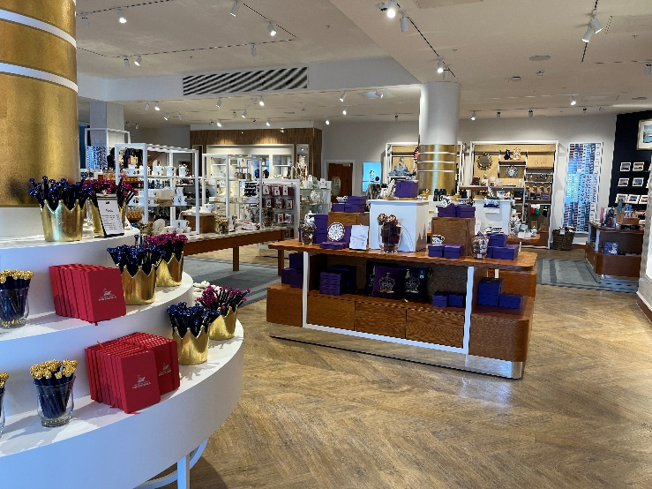
(Displays inside the Britannia Shop.)

- The highest shelf within the Shop is outwith reach, but staff will be very happy to help you.
- A magnifying glass is available to borrow from the till point.
- There are three areas of seating within the Shop.

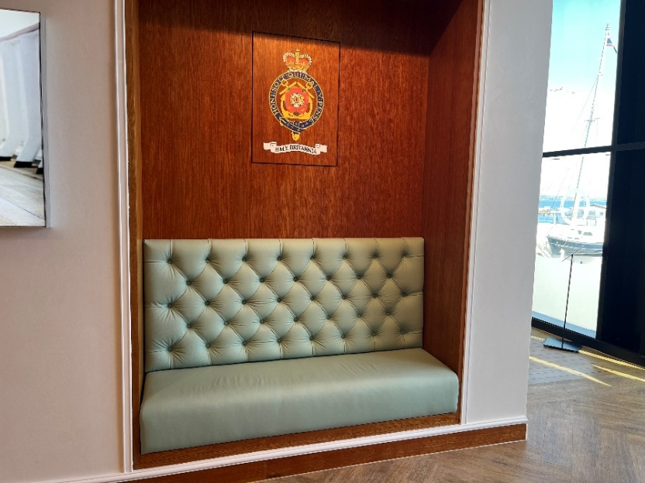
(Seating area in the Shop.)

- There are large windows in the Shop that overlook Britannia at height.
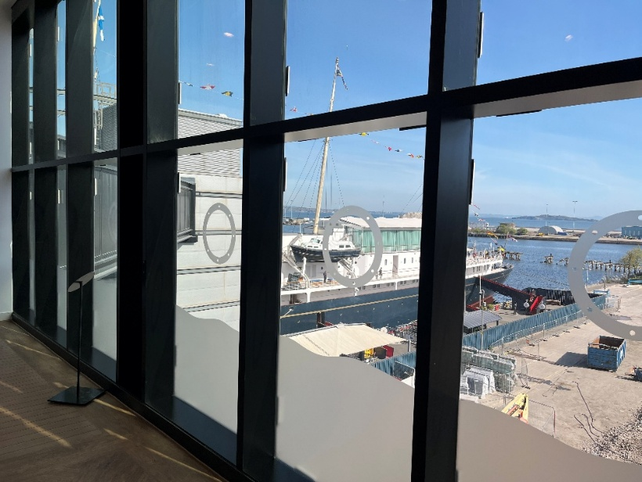
(Large windows after the Handset Desk and before entering the Shop.)

There is background music in the shop and a video, which plays on a screen behind the Shop tills, with sound. There is a hearing loop system within the Shop. Britannia staff are happy to offer assistance where required.

Additional Information

Assistance dogs
Assistance dogs are welcome on board Britannia. We have dog water bowls located in the Visitor Centre, in the Shop and outside on the Quayside by the Royal Barge, next to the statue of a Former Royal Yachtsman. Should your dog require the toilet, please ask a member of our team who will be happy to escort you to our onboard facilities.

Evacuation Chair
In the event of an evacuation on board, we have an Evac Chair – The World’s No.1 Stairway Evacuation chair, which trained members of our team will administer on the day from the Tearoom.
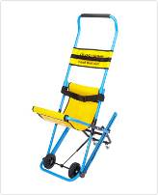
(Evacuation chair.)

Staff training
There is an ongoing programme of training with our staff.

First aid
There is a first aid room on board and there are members of staff who are trained in general first aid.

Smoking area
Smoking is not permitted within the Visitor Centre or on board. There is however a designated smoking area outdoor next to The Royal Barge, on the Quayside.

Local accommodation providers
The Holiday Inn Express is the nearest hotel to Britannia.
Holiday Inn Express, Britannia Way, Ocean Drive, Leith, Edinburgh, EH6 6JJ.

The Holiday Inn Express is 0.3 miles from Britannia. The Holiday Inn Express has 9 double accessible rooms with wheel-in access shower rooms. All rooms have flashing fire alarms, emergency lighting and emergency pull cords in both the bedroom and bathroom area. They also have a vibrating pillow that can be moved from room to room, which is linked to the fire alarm system to alert people who are deaf or have hearing loss should the fire alarm be activated. There is also an ‘Evac Chair’ so that disabled guests can evacuate the building in the event of a fire.

There are no accessible twin-bedrooms, however there are adjoining rooms for carers which are provided free-of-charge. Please note that these interconnecting rooms must be booked directly with the hotel to ensure availability.

There are no stairs at the entrance to the hotel. The reception desk has a lowered area. Both the bar and breakfast room are on the ground floor with easy access.
Contact details for The Holiday Inn Express:
www.expressedinburgh.co.uk/

Feedback
If you would like to provide us with any feedback on this Access Statement, we welcome your comments, as we are interested in finding out any information we may have missed that would be of interest to others. Please email us: enquiries@tryb.co.uk or by telephone +44 (0) 131 555 8800 or simply speak to a member of our team when you visit Britannia.

Contact information
Address: The Royal Yacht Britannia, Ocean Terminal, Leith, Edinburgh, EH6 6JJ
Contact our Marketing office during our office opening hours, Monday to Friday, 9am to 5pm. Telephone: +44 (0) 131 555 8800.
Email: enquiries@tryb.co.uk
Website: www.royalyachtbritannia.co.uk

